Lesson – 17

Garbage in garbage out

**I. Vocabulary**

1. Segregation
2. Degradation
3. Biodegradable
4. Non- biodegradable
5. Composting
6. Red worms
7. Vermicomposting
8. Landfills
9. Reduce
10. Reuse
11. Recycle
12. Disposable

**II. KWL Chart**

**III. Concept map**

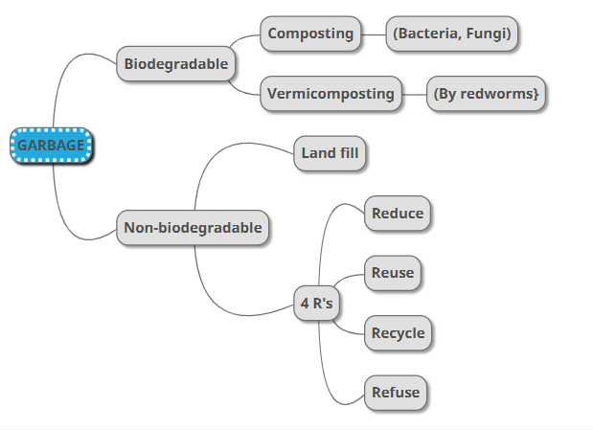

**IV. Answer the following**

1. What is garbage?

Garbage or waste may be in the form of fruit or vegetable peels, discarded objects, wrapping materials, wasted food, household garbage or discarded chemicals and fertilizers washed into rivers, domestic sewage, etc.

2. Differentiate between biodegradable and non- biodegradable waste with example.

Stick only pictures

3. What is compost? How can we make a vermin compost?

* Recycling of organic waste, such as vegetable peels, waste food, and leaves by burying them in compost pits is called composting.
* The biodegradable wastes are degraded by the action of small organisms such as bacteria and fungi.
* When we use red worms (a type of earthworm) to break down waste, the compost produced is called vermicompost. These worms decompose the waste faster, and the compost formed is rich in nutrients.

4. Define landfill. List some methods for the management of non-biodegradable wastes.

Large areas used for waste disposal are called landfills.

The methods for the management of non-biodegradable wastes are

* Reduce
* Reuse
* Recycle
* Refuse

5. Collect the data of Coimbatore Corporation regarding the amount of domestic waste collected for 10 days and the methods of dispersal.